ROYAL FREE HOSPITAL NHS TRUST

university college London
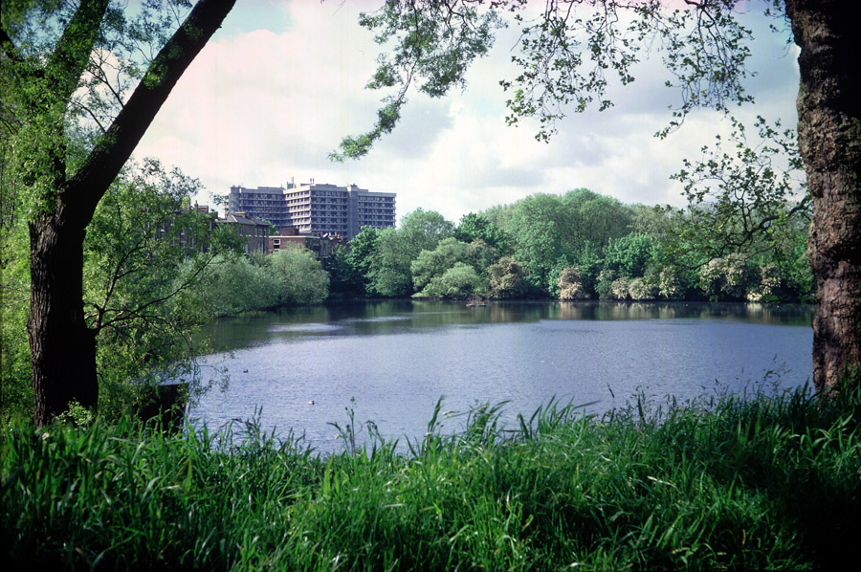

clinical research fellowship
&
Attatchements

Introduction
The Royal Free London NHS Foundation Trust has approximately 500 beds on its own sites. About 5,000 people are employed, and the annual turnover in 2014/15 is expected to be approximately £900 million.

As well as services for local people, such as accident and emergency services, and all branches of surgery and medicine, the trust is renowned for a large number of specialist services. These include, amongst others, solid organ and bone marrow transplantation, nephrology and hepatology, HIV and infectious diseases, plastic surgery, immunology, paediatric gastroenterology, amyloidosis and scleroderma. The Royal Free is a leading cancer centre with a range of specialist diagnostic and treatment services in oncology and haematology, and a major neuroscience base with a network extending throughout north London, Hertfordshire and Bedfordshire.

The Royal Free’s research priorities in collaboration with the medical school are translational and clinical research underpinned by a strong basic science. Areas of particular research excellence include organ failure and transplantation, haematology and oncology, immunity, inflammation, and neurosciences.

In August 2008 the Royal Free became a founder member of UCL Partners, a federation of UCL with associated specialist trusts. UCL Partners was designated as an academic health science centre by the secretary of state in March 2009.

In 2012 the Royal Free became an NHS Foundation Trust. In 2014 aquired Barnet and Chase Farm Hospital.

https://www.royalfree.nhs.uk/about-us/our-history/

2. Early history

The Royal Free Hospital was founded in 1828 by William Marsden, a surgeon who later also founded the Marsden Hospital. It was the first hospital in London, and one of the first in the country, to treat patients without any letter of introduction or payment. In the 1840s it moved to Gray’s Inn Road. The hospital was given its royal title by Queen Victoria in recognition of its work during cholera outbreaks.

3. Today

In the 21st century, we continue to lead improvements in healthcare, from targeted cancer therapies to new kinds of surgery. We offer an exceptionally wide range of local and specialist services, and are proud to have some of the best clinical outcomes in the country. We see around 700,000 patients a year from all over the world.

We are a campus of UCL Medical School and conduct important medical research. We also train doctors, nurses, midwives and many other clinical and non-clinical professionals. We helped to set up the academic health science centre, UCL Partners.

We were Dr Foster's 'large trust of the year' for 2010 and were particularly praised for our patient safety and infection control record. We are ranked among the best English trusts for mortality rates - our rate is 25 per cent below that expected. Our infection rates are some of the lowest in London teaching hospitals.

On 1 April 2012 we were authorised as an NHS foundation trust by the regulator Monitor and are now known as the Royal Free London NHS Foundation Trust. We plan to use the greater freedoms this brings us to provide the best possible services for our patients and local community.

Our mission is to be in the top 10 per cent of English hospitals for clinical quality, customer satisfaction, staff satisfaction and financial performance. We want to give patients the best possible care in a safe, clean and welcoming environment.
Our commitment is to offer world class care so everyone at the Royal Free can feel welcomed all the time, respected and cared for, confident because we are communicating clearly and reassured that patients are in safe hands.

4. Organisation

Patient services are managed by three clinical divisions, each led by a clinically qualified divisional director, who is supported by a team of clinical directors, a director of operations and a nurse director. The divisions are:
- surgery and associated services
- urgent care
- transplantation immunology and specialist services

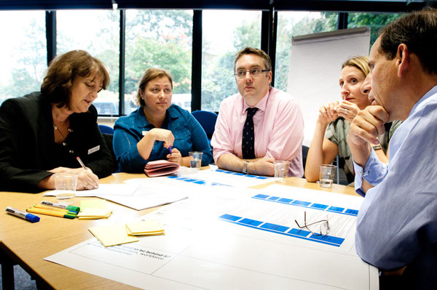

There is a separate private practice department. Consultants undertaking private patient work are encouraged to use the trust's facilities.

5. The University College London Medical School

University College London is the largest of over 50 colleges and institutes which make up the federal University of London and is consistently rated as one of the U.K.’s premier academic institutions. The Royal Free and University College Medical School of University College London is a general medical school in the Faculty of Medicine of the University of London, formed on 1 August 1998 by the merger of the Royal Free Hospital School of Medicine and University College School of Medicine. A joint Department of Medicine, with around 400 staff, has existed between the two Schools since January 1994. The Department encompasses a broad range of basic and clinical research programmes and undertakes teaching of undergraduates and postgraduates.

For further information on electives program:

http://www.ucl.ac.uk/medicalschool/undergraduate/electives

6. General&Emergency, Vascular, Breast, Colorectal and HPB surgery at the Royal Free

Consultant Staff

The current consultant staff complement is as follows:-

Professor George Hamilton Vascular Surgery – divisional director SAS
Professor Krassi Ivancev Vascular Surgery
Mr Daryll Baker Vascular Surgery
Miss Meryl Davis Vascular Surgery
Miss Fiona Myint Vascular Surgery
Miss Janice Tsui Vascular Surgery
Mr Obi Agu Vascular Surgery
Mr Toby Richards Vascular Surgery
Mr Richard Bird Vascular Surgery
Mr Christopher Bishop Vascular Surgery
Mr Nicholas Law Vascular Surgery
Mr Alex Loh Vascular Surgery
Mr Ben Lindsay Renal and Vascular Surgery

Professor Marc Winslet Colorectal Surgery
Mr Richard Novell Colorectal Surgery
Mr Olagunju Ogunbiyi Colorectal Surgery

Mr Massimo Varcada Emergency General and Laparoscopic Lower GI
Surgery –Clinical Lead
Mr Rovan D’Souza Emergency General and Vascular Surgery
Mr Colin Hart General and Emergency Surgery
Mr Jonathan Knowles Emergency General and Laparoscopic Lower GI
Surgery

Mr Tim Davidson Breast Surgery - clinical lead
Mr Mo Keshtgar Breast Surgery
Mr Deb Ghosh Breast Surgery

Professor Brian Davidson HPB surgery
Mr Dinesh Sharma HPB surgery
Mr Kito Fusai HPB surgery
Mr Zak Rahman Upper GI and HPB surgery Clinical Lead
Mr Charles Imber HPB surgery
Professor Max Malago HPB surgery
Mr Arj Shankar HPB surgery and Sarcoma

7. Undergraduate and postgraduate teaching duties expected of consultants

The Royal Free London NHS Foundation Trust is a major training centre for both undergraduates from the University College School of Medicine, UCL and also for postgraduates at FY1, FY2, CT 1/2 and specialist registrar level from the London Deanery.

https://www.royalfree.nhs.uk/teaching/undergraduate-teaching/undergraduate-medical-school-courses/

https://www.royalfree.nhs.uk/teaching/undergraduate-teaching

Research

Research and development is now a major component of the Royal Free Hampstead NHS Trust strategy and reflects the Trust’s desire to maintain its position as one of the top ten Trusts for R&D income in the UK. The research efforts of the Trust and Medical School are closely integrated and there are extensive facilities for both clinical and basis science research. Clinical Fellows are expected to participate in research according to their skills and speciality. An audit system for quality in R&D was introduced during 1998 and reflects an individual’s commitment to this area. Applicants should prepare an outline of the research they would wish to undertake once position offered.

Key areas for the development of research within the Division over the coming five-year period include:-
· Novel therapies (including Photodynamic Therapy) in the treatment of cancer.
· R&D of Nanotechnology in diagnostic and treatment of cancer.
· Clinical trials.
· Prostate cancer.
· Medical devices (vascular grafts, heart valves, musculoskeletal implants).
· Tissue engineering (including use of non-embryonic stem cells).
· Spinal research.
· Disability Science, accessibility and assistive technologies.
· Organ preservation, transplantation and ischaemia.
· Peri-operative medicine (risk modification and outcomes).
Divisional Courses: MSc in Musculoskeletal Science (Taught and Distance Learning), MSc in Trauma and Orthopaedics, MSc in Evidence Based Healthcare, MSc in Burns, Plastics and Reconstructive Surgery (new), MSc in Nanotechnology and Regenerative Medicine, MSc in Sports Medicine Exercise and Health (Taught and Distance Learning), MSc Performing Arts Medicine, MSc Urology, MSc in Surgical Science and Graduate Research.

Other:
MBBS, iBSc in Surgical Science and iBSc in Orthopaedic Science.

Details available at

www.ucl.ac.uk/surgicalscience
MSc in Evidence based Medicine
MSc in Nanotechnology and Regenerative Medicine

MEETING TIMETABLE

Monday | Anal Cancer MDM Upper GI MDM | 2nd floor, hystopathology dept. | 8.30 am  9.00 am
Tuesday | HPB MDM.  Vascular Radiology MDM | 2nd floor, hystopathology dept.  Ground Floor | 8.30 am  12.00 pm
Wednesday | Colorectal MDM  Breast MDM  IBD Gastro MDM | 4th floor oncology dept.  2nd floor, hystopathology dept.  2nd floor, simulation center | 8.30 am  8.00 am  8.00 am
Thursday
Friday | Research meeting Surgery HPB radiology MDM  Transplant MDM  M&M (last of the month) | 9th floor  Ground floor  9th floor  9th floor | 7.15 am  8.30 am  12.30 pm  14.00 pm

Fellowship description
The Academic Department of General and Colorectal Surgery at RFH maintains an average of six to twelve month non-funded clinical research positions in general and colorectal surgery. These positions are available to general or colorectal surgeons who wish to gain additional experience in both the practical and academic aspects of colorectal surgery. Clinical research fellow are requested to participate clinical and tutorial activities as time permits. There is a busy clinical practice with three full time Colorectal colorectal surgeons, and one Emergency and Colorectal. In addition there are nurses specialist who assist in patient care and help with much of the day-to-day patient management. This involvement allows the clinical fellow more time for interaction in the operating room, endoscopy suite, office, and multidisciplinary meeting. In addition, there are several dedicated colorectal clinic nurses, enterostomal therapists, and biofeedback therapists.
The clinical fellow will have full exposure to endoscopy and theatre lists, and will receive the same standard of training as UK colleagues. The colorectal Unit has an implemented endoscopy clinic and two endolaparoscopic theatre. There are facilities to participate in clinical activities from different subspecialties, as such breast, vascular, HPB and Liver Transplant.
COLORECTAL SURGERY
The clinical lead for colorectal surgery is Mr O.A.Ogunbiyi
The trust provides a specialist service in colorectal cancer, IBD, incontinence and the pelvic floor, neuroendocrine tumours, anorectal disease and paediatric gastroenterology.
Three full-time colorectal surgeons perform 70 - 100 colorectal cancer resections open and laparoscopic a year and manage the full range of bowel conditions. The department is supported by state-of-the-art diagnostic and interventional radiology and anorectal physiology services, and has strong links with clinical and medical oncology, gastroenterology, palliative care and primary care.
In-patient activity is based on 7 west and which have 40 beds. The department has nine operating lists per week and three endoscopy lists ( shared with Upper GI).
Clinics are held 5 times per week (Monday am, Tuesday am, Wednesday am and 2 on Friday am) which are located on the first floor, clinics 2 and 3.

Hepathology, Hepatobiliary and Transplant
This directorate exists within transplant and Immunology. It includes all aspects of liver, pancreatic and biliary medicine and surgery in the in-patient and out-patients settings. This includes liver transplantation, alcohol services and viral hepatitis. All medical gastroenterology and the endoscopy unit reside within this directorate.
The Hepatobiliary unit perform aprox. 80 liver transplant per year including heart beating and living donor. There are an average of 40 new cases per week of HPB pathology discussed at the MDM.
The directorate is divided into 4 clinical services under the auspices of the clinical director.
Clinical director - Mr Dinesh Sharma(consultant surgeon)
The clinical service leads are:
Gastroenterology – Ms Isobel mason Nurse Gastro)
Liver medicine – Dr Douglas Thorburn (consultant hepatologist)
HPB surgery – Mr Kito Fusai (consultant surgeon)
Liver transplantation - Mr Charles Imber (consultant surgeon)
The operations team are based on the 8th floor.

Residential accommodation
Royal Free Hospital residential accommodation portfolio ranges from single bedsitting rooms
sharing communal facilities to 2-bedroom self contained flats and is allocated subject to availability
and the current allocation policy.
Adhoc accommodation can also be provided subject to availability.
Queen Mary’s House – single bedsitting rooms, sharing communal facilities
Anne Bryans House – single ensuite bedsitting rooms, sharing kitchen and sitting room facilities.
Re-opened in April 2011 after complete refurbishment.
Coppetts Wood House – Self contained studios, one and two bedroom flats.
Princess Christian House – Self contained studio flats.
Contact: x33490 or x34716 – email: rfh.accommodation@nhs.net

Each residence is managed by the Trust’s housing partners:

Coppetts Wood House/Queen Mary’s House/Anne Bryans House
Managed by Newlon Housing Trust.
Area office based in Coppetts Wood House Phone: 0207 449 4300 Email: jay.shams@newlon.org.uk
Website: www.newlon.org.uk

Princess Christian House
Managed by Genesis Housing Association
Contact: Mr Jude Coney Phone: 0207 443 5547 Email: jude.coney@genesisha.org.uk
Website: www.genesisha.org.uk

